7.3.11 Editors - 3D View - Sidebar - Tool Tab - Grease Pencil Object
Tools Tab - Grease Pencil Object 4
Draw Mode - Brush Panel 4
Brush Browser 4
Create Presets 4
Custom Icon 4
Brush Name Edit Box 5
Draw Mode - Brush settings Panel 5
Header - Add Brush Preset 5
Material Browser 5
Dropdown box 6
Edit Box 6
With Draw Tools 6
Radius 6
Use Pressure 6
Strength 6
Use Pressure 6
With Fill Tool 6
Leak Size 6
Thickness 6
Simplify 7
With Eraser Tools 7
Radius 7
Use Pressure 7
Occlude Eraser 7
Mode 7
Disssolve 7
Point 7
Stroke 7
Display Cursor 7
Draw Mode - Brush settings Panel - Advanced Subpanel 7
With Draw Tool 7
Input Samples 7
Active Smooth 7
Angle 8
Factor 8
Border Opacity Factor 8
Aspect Ratio X / Y 8
With Fill Tool 8
Boundary 8
Show Lines 8
Resolution 8
Ignore transparent Strokes 8
Threshold 8
Draw Mode - Brush settings Panel - Stroke Subpanel 8
Post Processing 9
Smooth 9
Iterations 9
Smooth Thickness 9
Iterations 9
Subdivision Steps 9
Randomness 9
Simplify 9
Trim Stroke Ends 9
Randomize 9
Pressure 9
Strength 9
UV 9
Jitter 10
Use Pressure 10
Stabilize Stroke 10
Radius 10
Factor 10
Draw Mode - Brush settings Panel - Curves Subpanel 10
Navigation elements 10
Zoom in and out 10
Tools 10
Reset View 10
Vector Handle 10
Auto Handle 11
Auto Clamped Handle 11
Reset Curve 11
Use Clipping 11
Delete Points 11
Draw Mode - Brush settings Panel - Cursor Subpanel 11
Show Fill Color while drawing 11
Sculpt Mode 11
Sculpt Mode - Brushes Panel 11
Brush browser 11
Sculpt Mode - Brush Settings Panel 12
Radius 12
Strength 12
Weight 12
Use Falloff 12
Add / Subtract 12
Clockwise/Counter Clockwise 12
Pinch / Inflate 12
Sculpt Mode - Brush Settings Panel - Sculpt Strokes Subpanel 12
Affect Position, Strength, etc. 12
Sculpt Mode - Brush Settings Panel - Cursor Subpanel 13
Show Brush 13
Color 13
Grease Pencil - Weight Paint Mode 13
Weight Paint Mode - Brushes Panel 13
Brush browser 13
Weight Paint Mode - Brush Settings Panel 13
Radius 13
Strength 13
Weight 13
Use Falloff 14
Weight Paint Mode - Brush Settings Panel - Cursor Subpanel 14
Show Brush 14
Color 14

Tools Tab - Grease Pencil Object

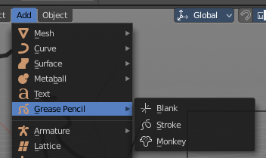
The Grease Pencil Object is a very special object which deserves its own chapter. Even when it has some modes that other objects has too. It is simply too special.

The Grease Pencil Object allows you to draw in 2D in the workspace.

It starts as an object type. By switchting into paint mode it becomes a paint feature. And editing turns it into a curve or a mesh object then.

In the Tools tab you will find all the options and settings for drawing and manipulating the grease pencil object, means your drawing.

The type Blank allows you to draw strokes.
The type Stroke allows you to draw filled forms.
The type Monkey is just an example object.

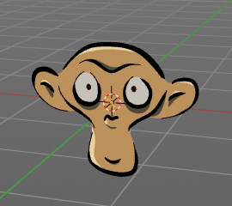
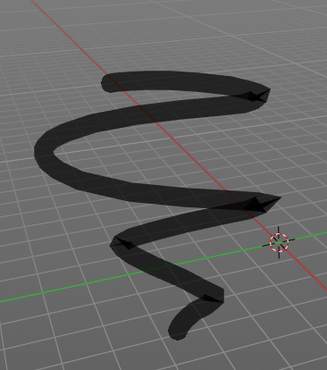
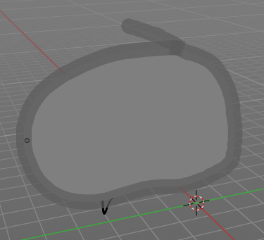

Draw Mode - Brush Panel
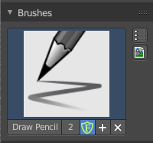

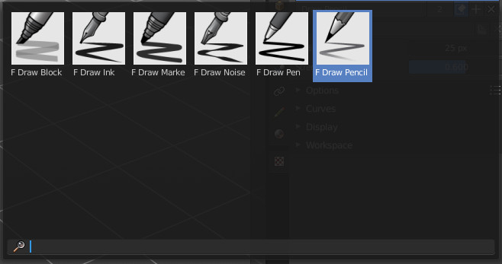
Brush Browser
Here you can choose between the different draw, fill and erase brushes. It's the same than in the tool shelf.

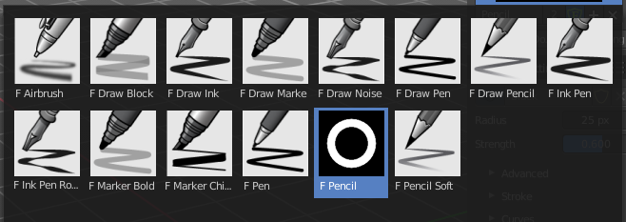

Create Presets
Here you can create a brush preset set that you can further modify.

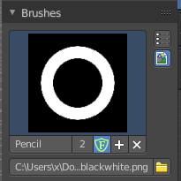
Custom Icon
The button at the right allows you to load a custom icon for your brush. It reveals a file browser below the image browser.

Brush Name Edit Box
The edit box below the Image shows you the name of the current active brush.
The number right of it, in this case 2, indicates how much number of users ( internally ) this brush uses. This means that this data block (the brush) shares currently settings with at least one other object. Most probably the parent brush where we have created it from. Click at the value to make this brush a single user. The button will vanish then.
Fake User set the brush to have a fake user. Zero user data-blocks are normally not saved. But sometimes you want to force the data to be kept even when the data block has no user.
The + button allows you to add a new pencil with the current settings. Note that the brushes are NOT saved when you close Bforartists. You can save them into the current blend file. Or you can save the startup file. But be careful here. This saves everything else of the current state of Bforartists too.
The X button deletes the brush as the active one. It does NOT delete it from the brushes list.

Draw Mode - Brush settings Panel

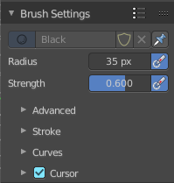

Header - Add Brush Preset
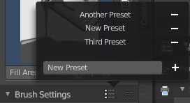
In the header is a brush preset menu where you can store and load custom brush presets. The dialog should be self explaining. In the edit box you type in the name of your new preset. And with clicking at the + button the new preset gets stored. Existing presets can be removed by clicking at the - button at the right side of the preset.

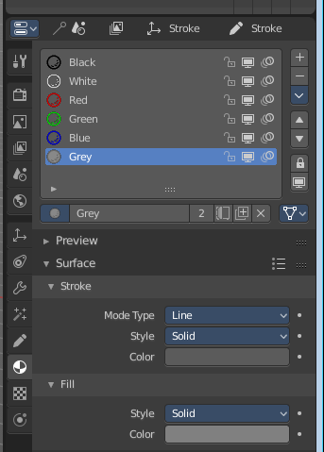
Material Browser
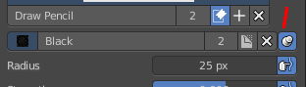
This browser is just active when the Keep material assigned to Brush Pin is activated.
The colors for the grease pencil are materials each. For the grease pencil type Blank you will just have one color available. For this type you have to cteate new matertials in the material tab first when you need more colors. But the other two types, strokes and monkey, comes with a few base materials already. Which can be found in the Materials tab.

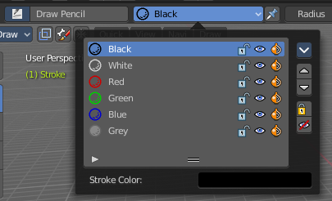
The tool settings above the header shows this panel too. And here you can quickly change the color of a material. It is explained in the chapter Materials Tab.

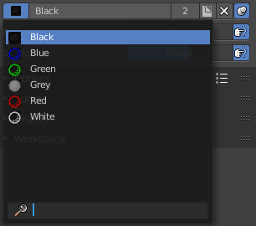
Dropdown box
Here you can choose another material to draw with.

Edit Box
Here you can read and modify the material name.
F set the material to have a fake user. Zero user data-blocks are normally not saved. But sometimes you want to force the data to be kept even when the data block has no user.
The X button deletes the material as the active one. It does NOT delete it from the materials list.
Keep material assigned to Brush Pin pins the brush to this material.

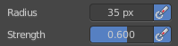
With Draw Tools

Radius
The Radius edit box allows you to adjust the radius of the brush.

Use Pressure
The button behind the edit box enables tablet pressure sensitivity for radius.

Strength
The Strength edit box allows you to adjust the strength of the brush.

Use Pressure
The button behind the edit box enables tablet pressure sensitivity for strength.

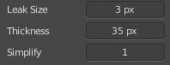
With Fill Tool
Note that the Fill tool does not fill an existing stroke like you would expect. It extends existing strokes with closed areas, or the border.

Leak Size
Size in pixels to consider the leak closed.

Thickness
The thickness of the new created stroke drawn with the fill tool around existing strokes or the border.

Simplify
Number of simplify steps.

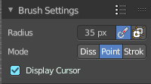
With Eraser Tools

Radius
The radius of the eraser brush.

Use Pressure
The button behind the edit box enables tablet pressure sensitivity for strength.

Occlude Eraser
Erase only visible and not occluded strokes.

Mode

Disssolve
Erase strokes, fading their points strength and thickness.

Point
Erase stroke points.

Stroke
Erase entire strokes.

Display Cursor
Show the eraser cursor.

Draw Mode - Brush settings Panel - Advanced Subpanel

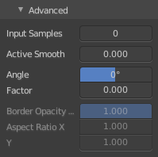
With Draw Tool

Input Samples
Generate intermediate Points for very fast mouse movements. A value of 0 means this feature is disabled.

Active Smooth
The amount of smoothing the strokes while drawing.

Angle
Direction of the stroke at which it gives the biggest thickness.

Factor
Reduce the brush thickness by this amount when the stroke is perpendicular to "Angle" direction.

Border Opacity Factor
Amount of transparency (alpha) to apply from the border of the point to the center. Works only when the brush is using stroke materials of Dot or Box style.

Aspect Ratio X / Y
The width and height of the alpha gradient.
It is unfortunately not to find out where this ominous Dot or Box Style material is to find or to create. So please ignore this settings for now. They are greyed out anyways. Maybe this will solve itself at a later development state.

With Fill Tool

Boundary
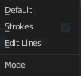
The mode to draw the boundary lines.

Show Lines
Show help lines for filling to see boundaries.

Resolution
Multiplier for the fill resolution. Higher resolution is slower but more accurate.

Ignore transparent Strokes
Show transparent lines to use as boundary for filling.

Threshold
Threshold to consider a color as transparent for filling.

Draw Mode - Brush settings Panel - Stroke Subpanel

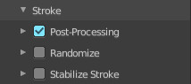
Here you will find some further stroke related settings. It has three sub sections. Post Processing, Randomize and Stabilize Stroke.

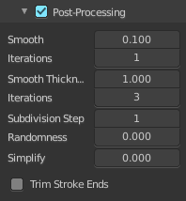
Post Processing
Here you find some post processing settings for new strokes.

Smooth
The smooth amount to reduce jittering.

Iterations
Number of iterations to smooth new created strokes.

Smooth Thickness
Amount of thickness smoothing to reduce jittering.

Iterations
Number of iterations to smooth new created strokes.

Subdivision Steps
Number of subdivisions of new created strokes

Randomness
Randomness factor for new created strokes after subdivision.

Simplify
Simplify new created strokes.

Trim Stroke Ends
Trim intersecting stroke ends.

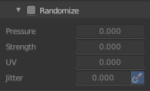
Randomize
Here you can add some randomization to the stroke.

Pressure
Randomize the pressure.

Strength
Randomize the strength.

UV
Randomize the auto generated UV rotation.

Jitter
Add Jitter

Use Pressure
The button behind the edit box enables tablet pressure sensitivity.

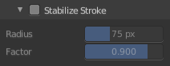
Stabilize Stroke
Draw lines with a delay to allow smooth strokes.

Radius
The minimum distance from last point before the stroke continues.

Factor
Smooth stroke factor. Higher values gives smoother stroke.

Draw Mode - Brush settings Panel - Curves Subpanel
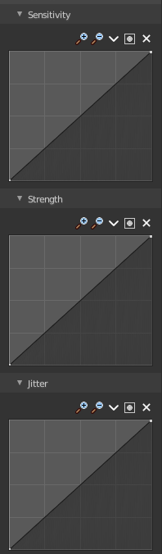
Here you can see and manipulate the curves for drawing Sensitivity, Strength and Jitter.

The navigation elements are the same for all three curve types.

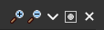
Navigation elements
The navigation elements at the top are described from left to right.

Zoom in and out
The two buttons with the magnifying glass at it zooms in and out in the curve window.

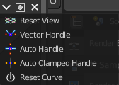
Tools
Tools is a menu where you can find some cuve related tools.

Reset View
Resets the curve windows zoom.

Vector Handle
Set handle type to Vector.

Auto Handle
Set handle type to Auto.

Auto Clamped Handle
Set handle type to Auto Clamped.

Reset Curve
Resets the curve to the initial shape.

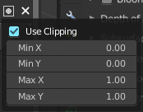
Use Clipping
Clipping options. Here you can set up clipping for the stroke.

Delete Points
Deletes selected curve points.

Draw Mode - Brush settings Panel - Cursor Subpanel
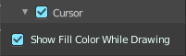
Show the brush cursor under the mouse.

Show Fill Color while drawing
Show the fill color of the grease pencil while drawing.

Sculpt Mode

In Sculpt mode you can sculpt the grease pencil strokes.

Sculpt Mode - Brushes Panel

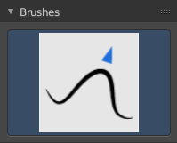
Brush browser
Here you can pick a pencil, and see what pencil is active.
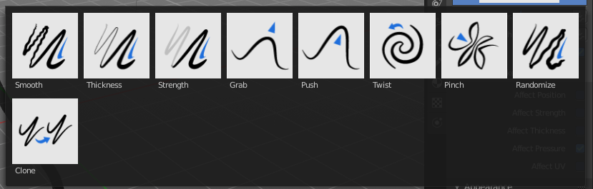

Sculpt Mode - Brush Settings Panel

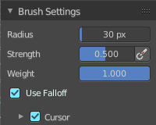
Radius
The radius of the brush.

Strength
The strength of the brush.

Weight
The target weight. Everything below gets added towards this value. Everything above gets subtracted from this value. Usually you work with the maximum value of 1.

Use Falloff
Use Falloff for the brush.

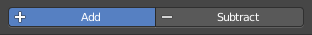
Add / Subtract
Thickness and Strength brush. If this brush should add or subtract to the sculpt surface.

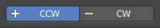
Clockwise/Counter Clockwise
Twist brush. If the twist goes clockwise or counter clockwise.


Pinch / Inflate
Pinch brush. If the brush should pinch or inflate.

Sculpt Mode - Brush Settings Panel - Sculpt Strokes Subpanel
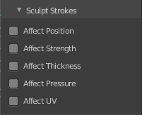

Affect Position, Strength, etc.
Make the strokes affect the listed items too.

Sculpt Mode - Brush Settings Panel - Cursor Subpanel
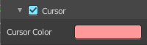

Show Brush
Show the brush icon when painting.

Color
The brush icon color.

Grease Pencil - Weight Paint Mode

In Weight Paint Mode you can weight paint your strokes.

Weight Paint Mode - Brushes Panel

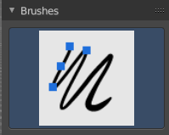
Brush browser
Here you can pick a pencil, and see what pencil is active. There is just one pencil available for weightpainting.
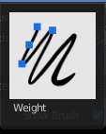

Weight Paint Mode - Brush Settings Panel

Radius
The radius of the brush.

Strength
The strength of the brush.

Weight
The target weight. Everything below gets added towards this value. Everything above gets subtracted from this value. Usually you work with the maximum value of 1.

Use Falloff
Use Falloff for the brush.

Weight Paint Mode - Brush Settings Panel - Cursor Subpanel

Show Brush
Show the brush icon when painting.

Color
The brush icon color.

